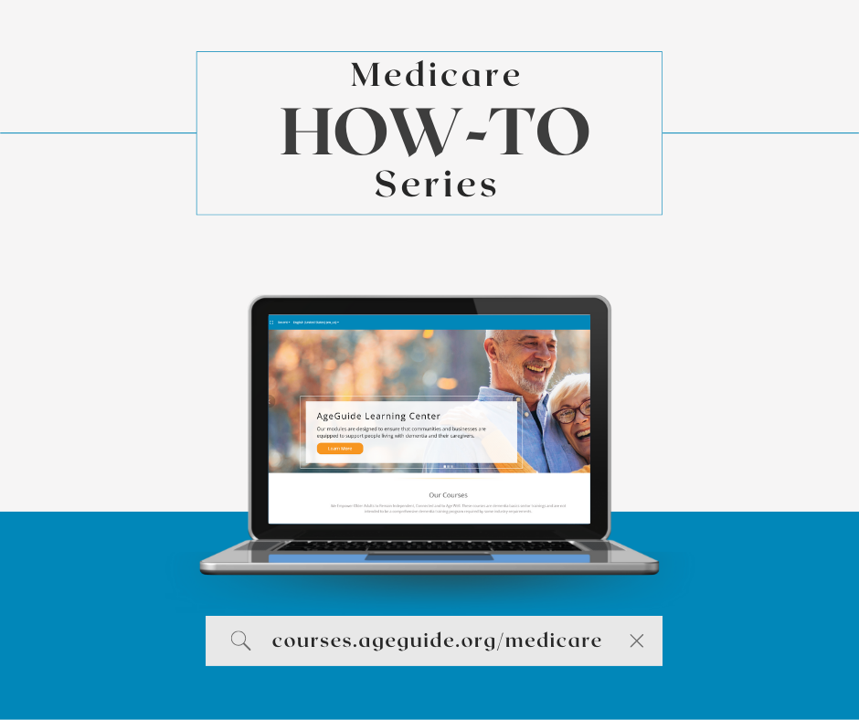

Facebook: Enrolling in Medicare can seem intimidating. AgeGuide’s new Medicare How-To Series on the AgeGuide Learning Center walks you through parts of the Medicare enrollment process and how to sign up. Videos are accessible in English, Spanish, Polish, Chinese, and Hindi. Visit https://courses.ageguide.org/medicare to begin today!
Twitter: Enrolling in Medicare can seem intimidating. AgeGuide's new Medicare How-To Series on the AgeGuide Learning Center walks you through aspects of the Open Enrollment process. Videos are accessible in multiple languages. Visit courses.ageguide.org/medicare to begin today! #MedicareOE

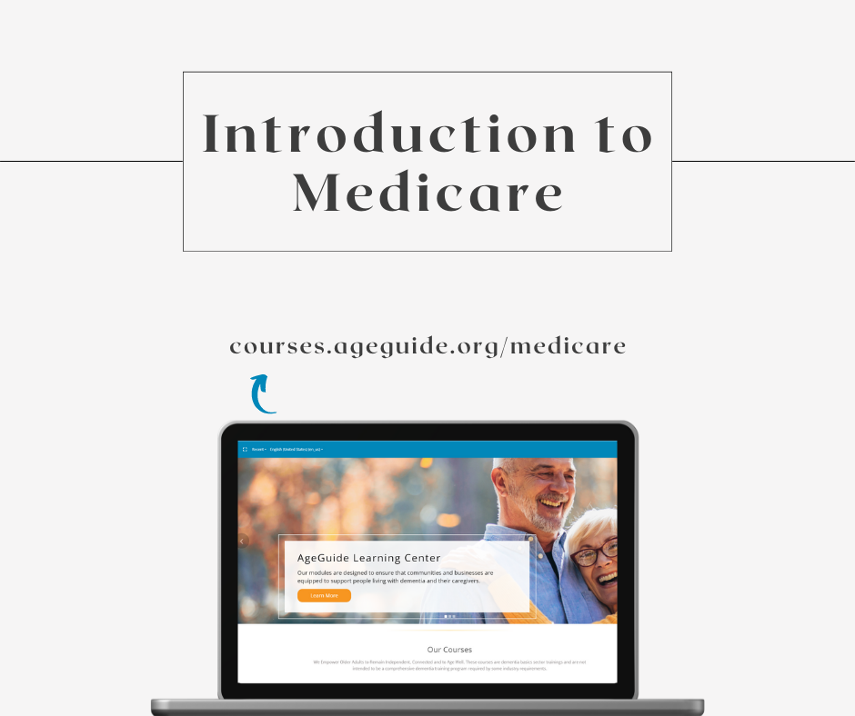

Facebook: The Medicare homepage is your first stop in your Medicare journey. The first video in the Medicare How-To Series covers where you can find the basics of Medicare, find and compare health and drug plans, coverage options, Medicare Supplemental Insurance, learn what health plans cover and how they work other coverage on the Medicare homepage. Watch the Introduction to Medicare video at courses.ageguide.org/medicare
Twitter: The Medicare homepage is your first stop in your Medicare journey. The first Medicare How-To video covers where you can find the basics of Medicare and more on the Medicare homepage. Watch the Introduction to Medicare video at courses.ageguide.org/medicare #MedicareOE

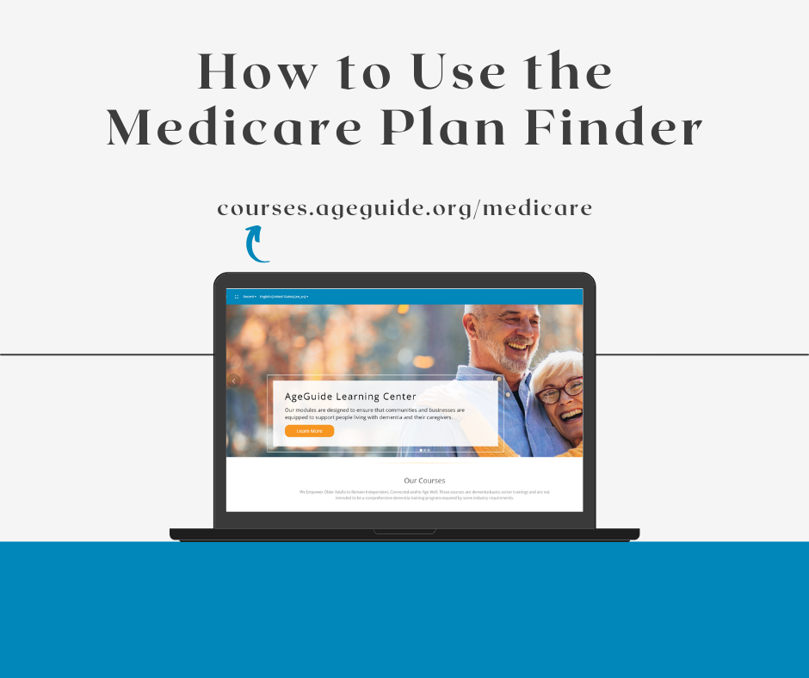

Facebook: When using the Medicare Plan Finder, you can shop and compare Medicare Part D and Medicare Advantage Plans. The How to Use the Medicare Plan Finder video goes into depth about the differences in the plans available and how to use the Medicare Plan Finder to compare plans. Watch this How-To video at courses.ageguide.org
Twitter: When using the Medicare Plan Finder, you can shop and compare Medicare Part D and Medicare Advantage Plans. The How to Use the Medicare Plan Finder takes an in-depth look at how to use the Medicare Plan Finder. Watch this How-To video at courses.ageguide.org/medicare #MedicareOE

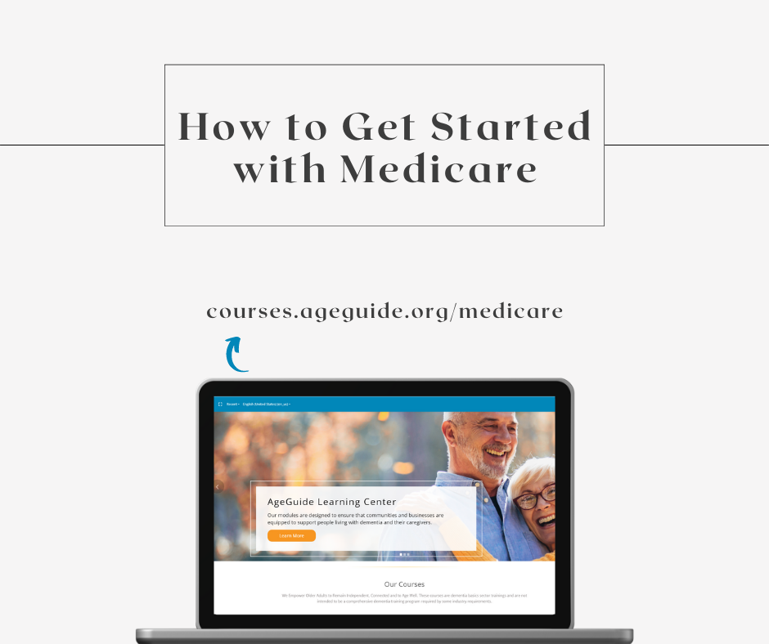
Facebook: Medicare.gov is a good place to start when learning about your health coverage options under Medicare. When getting started with Medicare, it is helpful to gain insight into how Medicare works and what to expect. The Getting Started with Medicare video explains when you are eligible, Medicare basics, how to sign up, exploring your coverage options and how to start using Medicare. Watch this How-To video at courses.ageguide.org
Twitter: Medicare.gov is a good place to start when learning about your health coverage options. The Getting Started with Medicare video explains Medicare basics, exploring coverage options and more. Watch this How-To video at courses.ageguide.org/medicare #MedicareOE

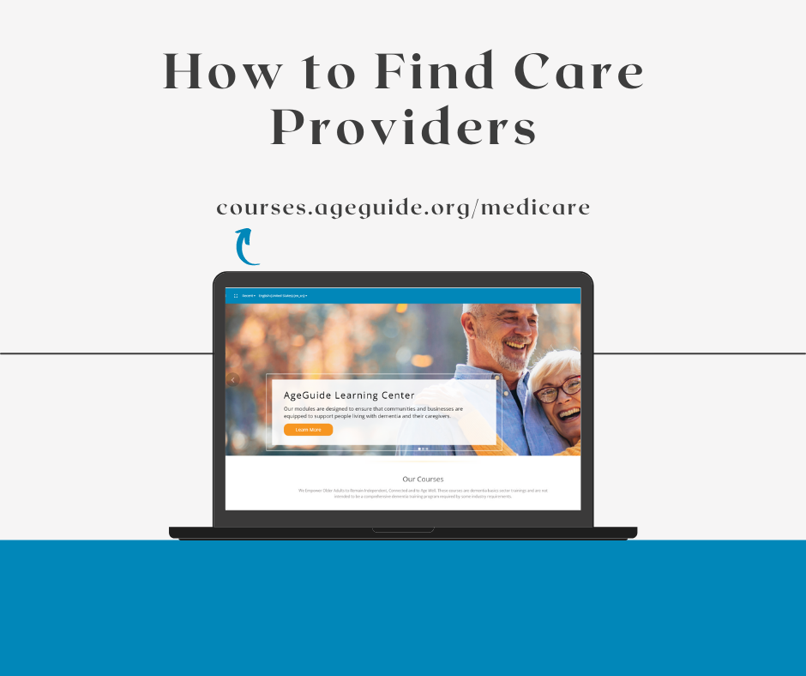
Facebook: Mediare.gov can help you compare nursing homes, hospitals, and other health care providers. This How-To video will walk you through how to search for a provider based on your location, how to compare providers based on ratings and more. Watch this How-To video at courses.ageguide.org
Twitter: Mediare.gov can help you compare nursing homes, hospitals, and other health care providers. This How-To video will walk you through how to search for a provider, how to compare providers based on ratings and more. Watch this How-To video at courses.ageguide.org/medicare

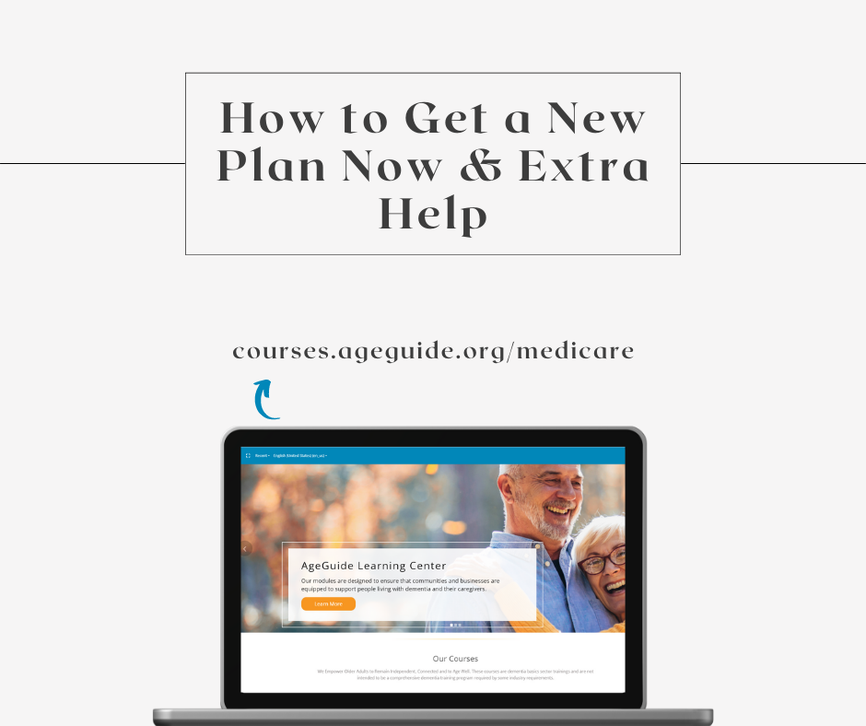
Facebook: Medicare has several different enrollment periods dictating when you can sign up for a plan or make changes to your current coverage. If you are newly eligible for Medicare or something sudden happens, you may need to find out if you can get a new plan now. This How-To video covers how you would be eligible for a special enrollment period and the qualifications for the Extra Help program. Watch this How-To video at courses.ageguide.org
Twitter: Medicare has several different enrollment periods dictating when you can sign up for a plan or make changes to current coverage. This How-To video covers special enrollment periods and the Extra Help program. Watch this How-To video at courses.ageguide.org/medicare #MedicareOE

