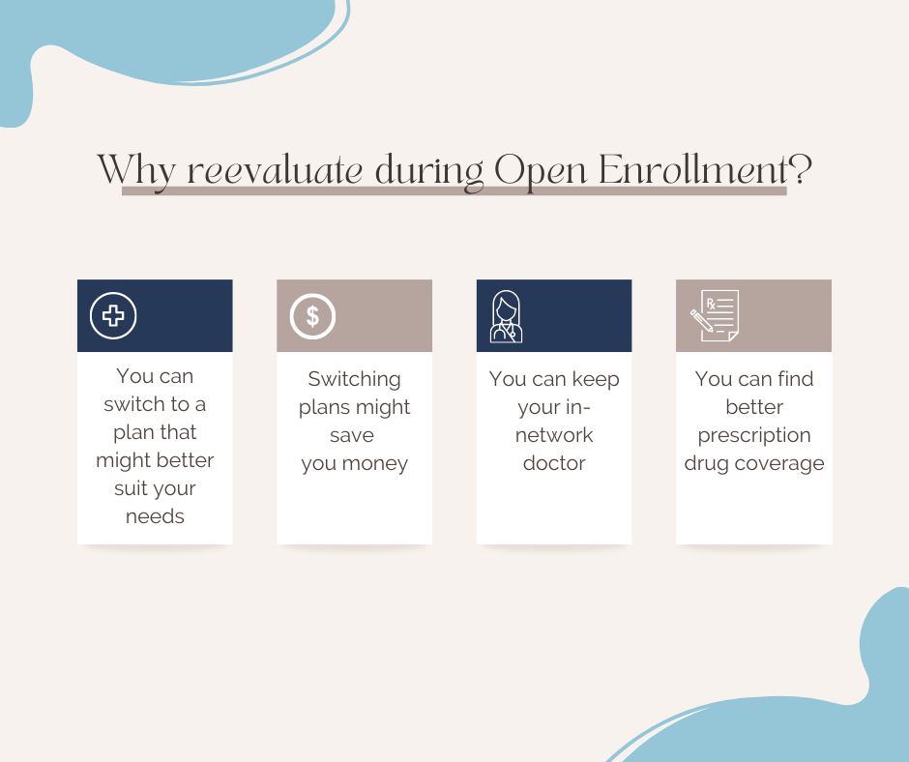
Facebook: Your health needs can change from year to year. The open enrollment period is a great time to evaluate your needs and make sure your plan is the best option for you and your needs. Start comparing plans at www.medicare.gov/plan-compare
Twitter: Your health needs can change from year to year. The open enrollment period is a great time to evaluate your needs and make sure your plan is the best option for you and your needs. Start comparing plans at www.medicare.gov/plan-compare #MedicareOE #ILOlderAdults

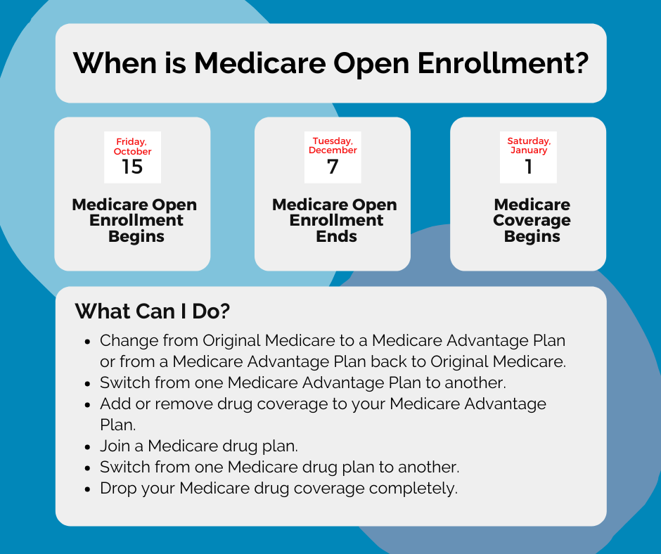
Facebook: Medicare Open Enrollment begins October 15th and ends December 7th. Take this time to change plans, evaluate drug plans, look at Medicare Advantage Plans and more! Find the plan that works best for you and your healthcare needs. Visit www.medicare.gov to get started today.
Twitter: #MedicareOE begins October 15th and ends December 7th. Take this time to change plans, evaluate drug plans, look at Medicare Advantage Plans and more! Find the plan that works best for you and your healthcare needs. Visit www.medicare.gov to get started today.
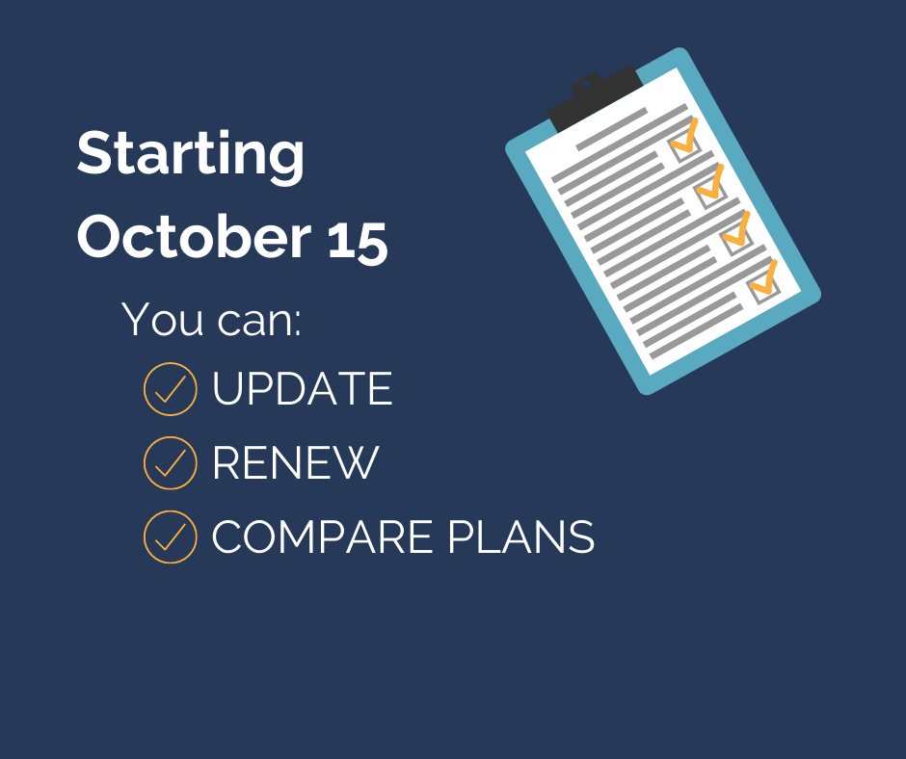
Facebook: Beginning October 15th, you can update, renew, and compare plans on the new Medicare Plan Finder. Shop for the plan that’s right for you! Get started at www.medicare.gov/plan-compare today!
Twitter: Beginning October 15th, you can update, renew, and compare plans on the new Medicare Plan Finder. Shop for the plan that’s right for you! Get started at www.medicare.gov/plan-compare today!

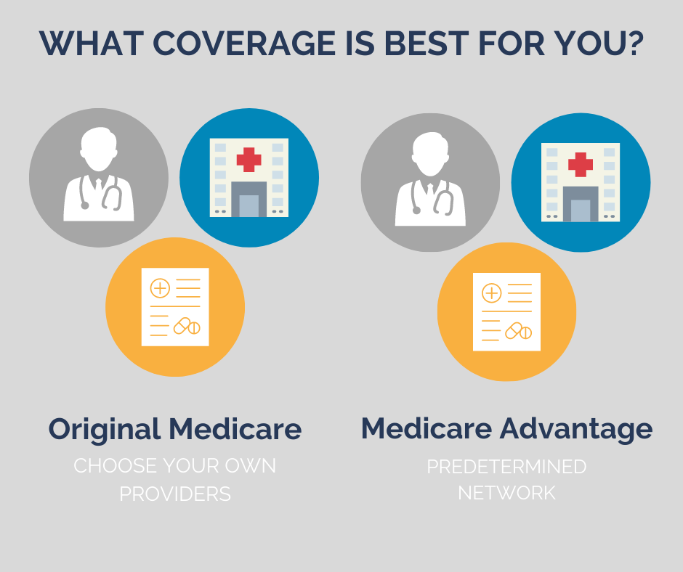
Facebook: Do you know the difference between Medicare and Medicare Advantage? One of the main differences is that with Original Medicare you can choose your own healthcare provider. With Medicare Advantage, you are required to use a healthcare provider within a predetermined network. Do you have questions? Your local SHIP counselor can help guide you to the best Medicare plan for you. Contact AgeGuide at (800) 528-2000 or visit www.ageguide.org/benefit-access-services for more information.
Twitter: #DYK the difference between Medicare and Medicare Advantage? Do you have questions about each plan? Your local #SHIP counselor can help guide you to the best plan for you. Contact AgeGuide at (800) 528-2000 or visit www.ageguide.org/benefit-access-services for more information. #MedicareOE
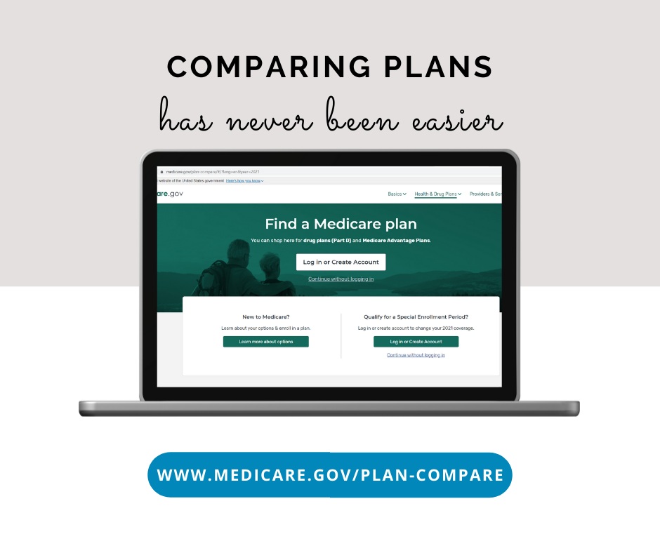
Facebook: Comparing Medicare plans has never been easier! Visit www.medicare.gov/plan-compare, answer a few simple questions and compare coverage options, shop for plans and choose the best one for your healthcare needs. Get started today!
Twitter: Comparing Medicare plans has never been easier! Visit www.medicare.gov/plan-compare, answer a few simple questions and compare coverage options, shop for plans and choose the best one for your healthcare needs. Get started today! #MedicareOE #ILOlderAdults

