Medicare Advantage Open Enrollment

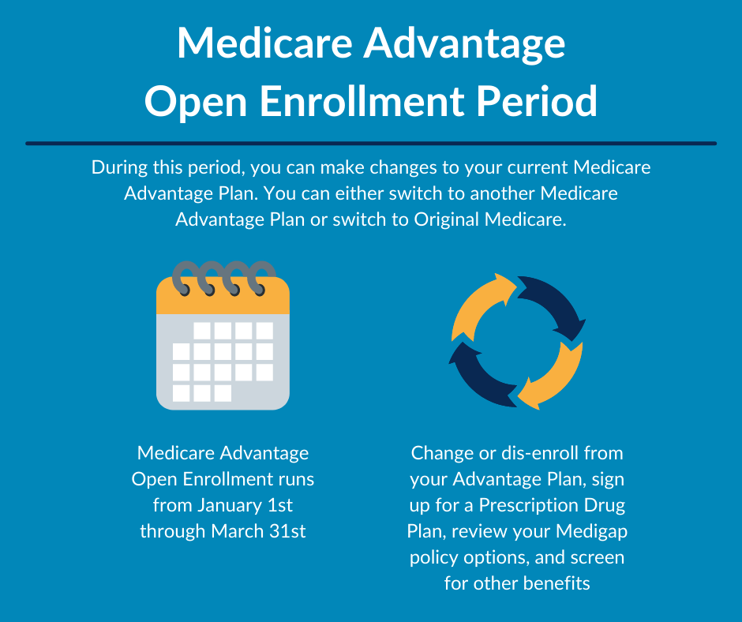

Medicare Advantage Open Enrollment runs from January 1 to March 31. Current Medicare Advantage enrollees can change to a different Advantage plan or drop their plan and switch to Original Medicare. A SHIP counselor can help you review your options to find the plan that works best for you.

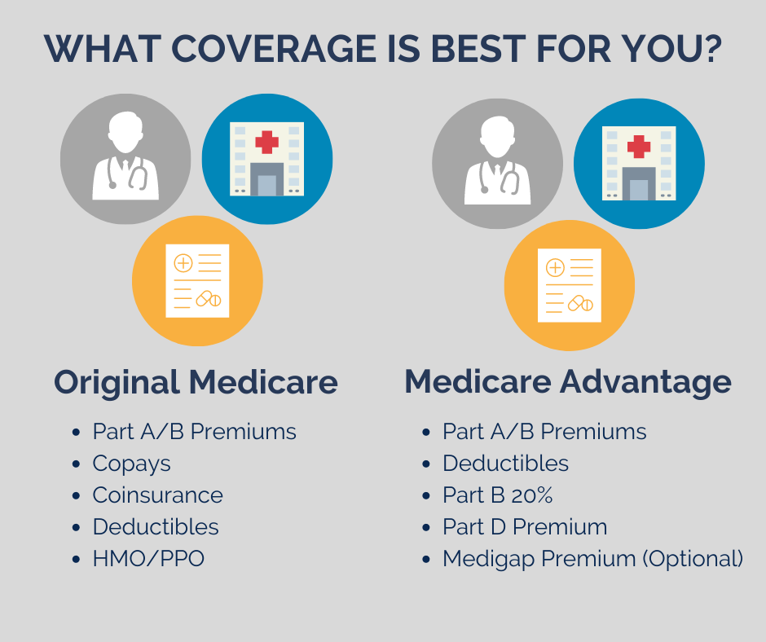
What you pay with Medicare can be different between Medicare Advantage and Original Medicare. Some people will pay less with one plan and some plans offer extra benefits. Your healthcare needs can help determine which plan will save you the most money. Speak with a SHIP counselor to compare your options during Medicare Advantage Open Enrollment.
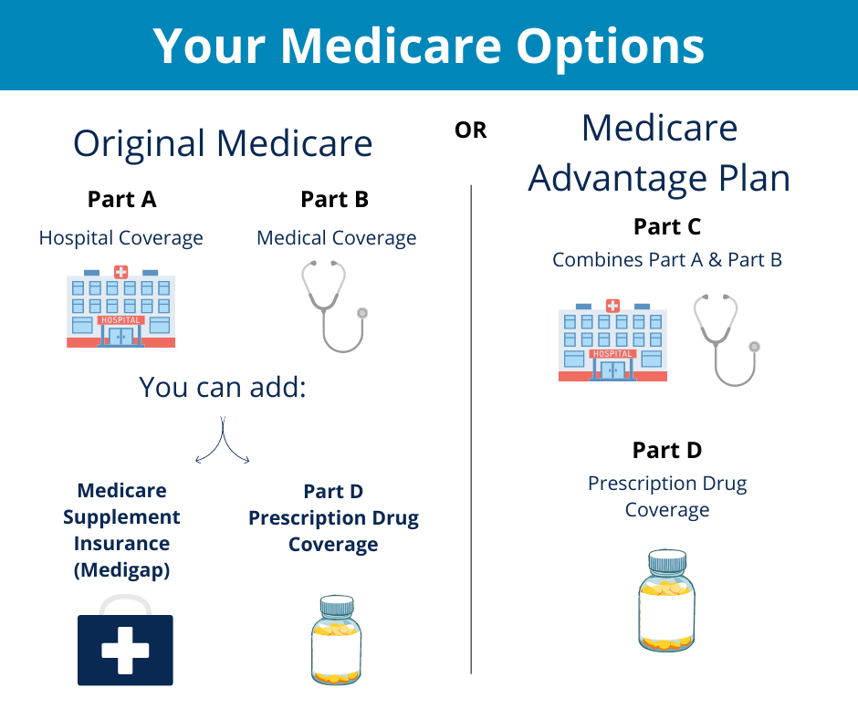

If you are dropping your Medicare Advantage plan and signing up for Original Medicare, you will need to make some important choices about your health coverage. You will need to shop and compare Part D prescription plans and consider supplemental coverage that can shield you from high out-of-pocket costs. A SHIP counselor can help you compare Part D plans and explain how supplemental coverage can keep your costs down.

New to Medicare

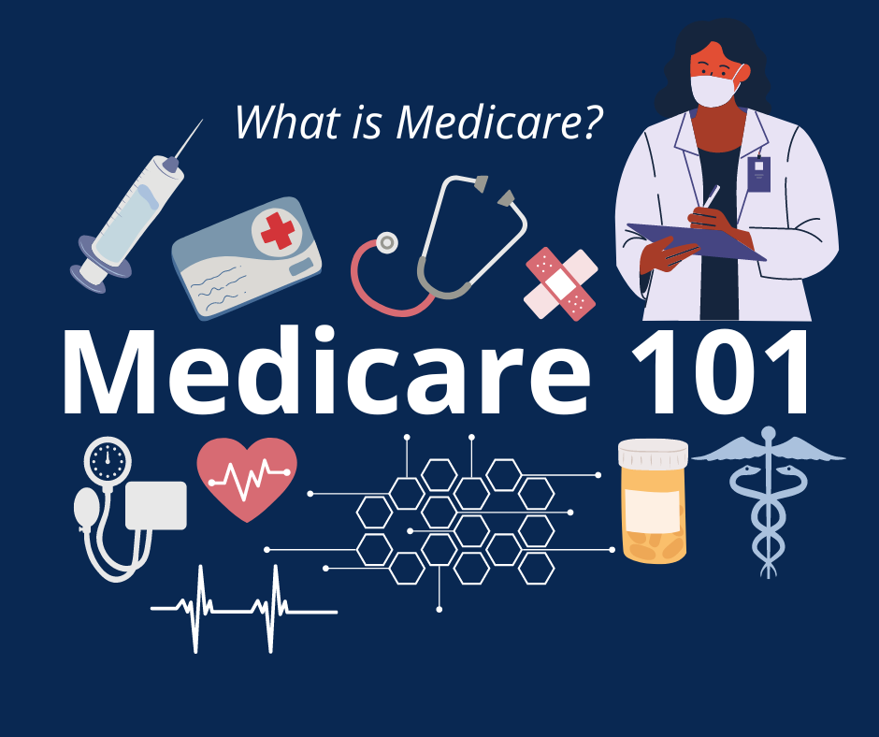
Being new to Medicare means you're grappling with Part A, Part B, Part C, and endless advertising so it's good to know that there is an unbiased resource that can guide you along the way. The Senior Health Insurance Program has trained counselors that know the ins and outs of Medicare. You can reach out to a SHIP counselor with any questions and to help you get started with Medicare.

Most people turning 65 are now eligible for Medicare. Before your 65th birthday you can start to plan how your health coverage with Medicare will be set up. Knowing your options and learning how Medicare works are important first steps. A Senior Health Insurance Program Counselor can get you started with the basics.

Retiring is a huge milestone, but you may have to make some very important decisions about your health care coverage. Switching from employer provided insurance to Medicare is a complicated process but SHIP counselors are here to help. Speak with a SHIP counselor to review your options with Medicare.

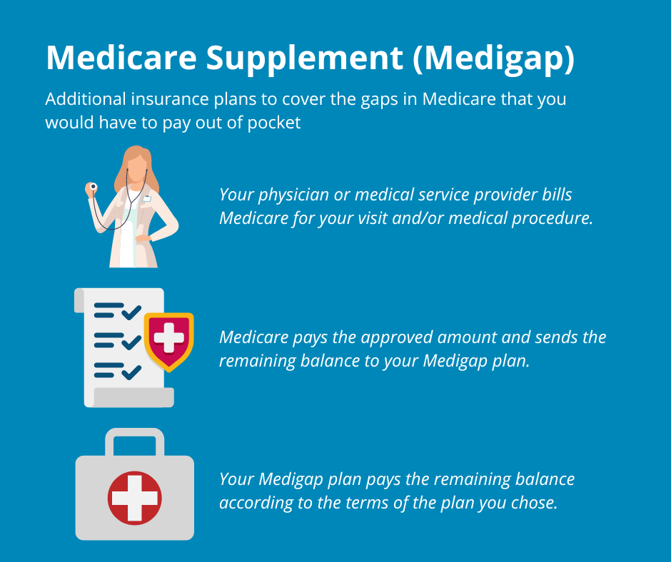
Medicare Supplemental Plans (also known as Medigap plans) can protect you from expensive out-of-pocket costs with Original Medicare. Medicare charges deductibles and coinsurance with no caps on how much you pay for health coverage. Medigap plans pay these costs for you. SHIP counselors can give you more information on how Medigap plans work and show you how to sign up.

Cost Savings Program
You may qualify for a benefit called "Extra Help" that gives you a discount on your medications and plans that have a $0 monthly premium would be available to you. "Extra Help" is a program offered by Social Security and there is more than one way that you can qualify. A Senior Health Insurance counselor can help you apply for the "Extra Help" program.

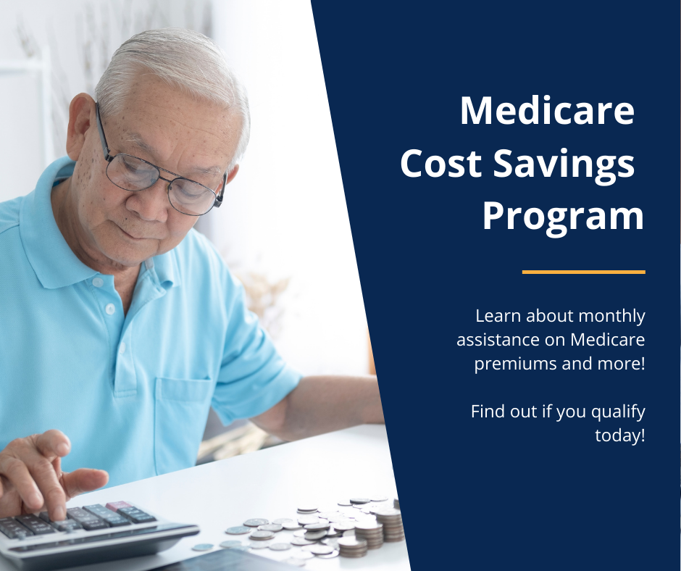

Medicare Savings Programs are available to help you pay for your Medicare monthly premiums. These State programs cover the monthly premiums of Medicare Part A, Part B, and for some Medicare deductibles and copayments. Senior Health Insurance Program counselors can tell you if you qualify for a Medicare Savings Program and help you apply.

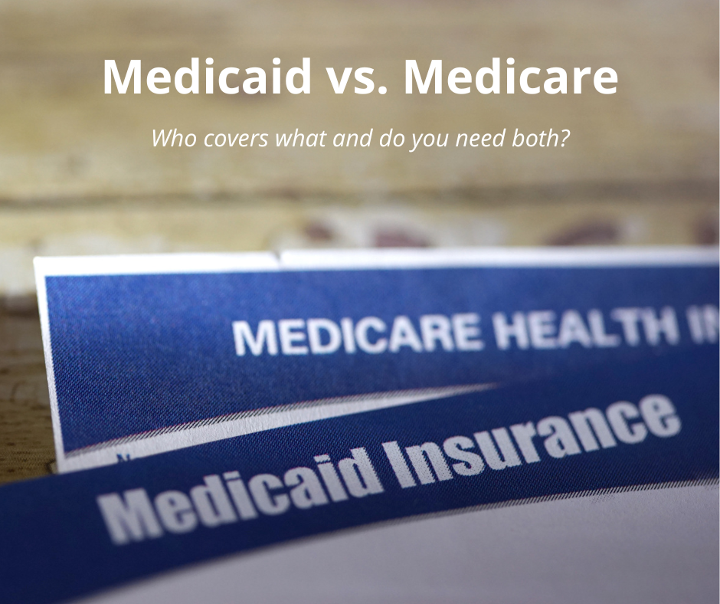
Medicaid is a State based health insurance program that works with Medicare to help pay your health care costs. Medicaid covers the 20% that Medicare normally bills to you, and it lowers the cost of your prescription drugs. You can also receive services through Medicaid that are not normally covered by Medicare. A Senior Health Insurance Program counselor can help you apply for Medicaid to gain access to these essential services.

